PERSONAL INFORMATION | Prof. em. Dr. Cristina Allemann-Ghionda
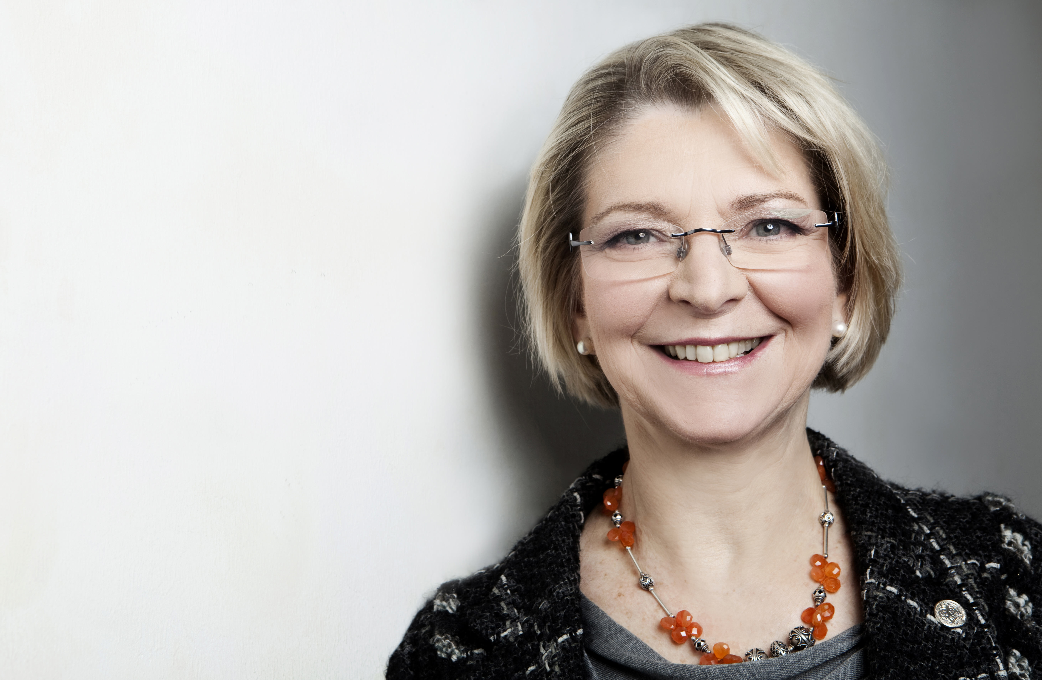 | Bannwartweg 26, 4058 Basel, Switzerland
 | +41(0)61-2222358
cristina.allemann-ghionda@uni-koeln.de
cristina.allemann-ghionda@unibas.ch

 | Sex Female | Date of birth 20/04/1949 | Nationality Italian and Swiss

Research focus | Comparative and intercultural studies (including empirical qualitative inquiries) on educational policies and theories, focussing curricular issues at the different levels of education, multilingualism and education, media and intercultural competence, time policies in education, diversity, (in)equality and inclusion in education, internationalization and diversity in higher education, intercultural and diversity issues in medicine; reflection on the epistemological foundations and on theoretical as well as policy discourses related to intercultural matters and, more generally, diversity.

WORK EXPERIENCE

from 2000 - to 2014 | Full Professor
 | University of Cologne
 | Comparative and Intercultural Education, since August 2014 emerita.

from 1998 - to 1999 | Maître d’Enseignement et de Recherche
 | Faculté de Psychologie et Sciences de l’Education, Université de Genève
 | Senior lecturer (Privatdozentin) Westfälische Wilhelms-Universität Münster

from 1993 - to 2000 | Researcher and senior lecturer
 | University of Berne
 | Two research projects funded by the Swiss National Science Foundation.

from 1990 - to 1992 | Lecturer
 | University of Zürich

from 1973 - to 1990 | Language Teacher / Manager in Adult Education / Researcher / Consultant
 | Freelance researcher and consultant in teacher education in Switzerland.

EDUCATION AND TRAINING

1998 Habilitation, Westfälische Wilhelms-Universität Münster, in educational sciences and comparative education.
1982 Doctorate (I) Università degli Studi di Torino
1973 Lic. Phil. I (equivalent of M.A.), University of Basel
(German, English and Italian linguistics and literatures)
1968 Abitur: Staatliches Nicolaus-Cusanus-Gymnasium, Bonn/Bad Godesberg.
Previous schooling in Belgium, Colombia, Peru, Italy, Germany.

PERSONAL SKILLS

Mother tongue(s) | Italian, German
Other language(s) | UNDERSTANDING |  | SPEAKING |  | WRITING
 | Listening | Reading | Spoken interaction | Spoken production
English | C2 | C2 | C2 | C1/C2 | C1/C2
 | Replace with name of language certificate. Enter level if known.
French | C2 | C2 | C1/C2 | C1/C2 | C1/C2
Spanish Listening and reading: C2; speaking and writing C1
Russian B2
Levels: A1/2: Basic user - B1/2: Independent user - C1/2 Proficient user
Common European Framework of Reference for Languages

Communication skills | Communication within large and small groups, gained through long experience as an academic teacher and previously as an adult educator; intercultural competence thanks to multicultural and multilingual biography, numerous international contacts (academic and private), and studies in intercultural communication and competence.

Organisational / managerial skills | Leadership in academic contexts: directing research projects; guiding research assistants, student assistants, and doctoral / post-doctoral students

Job-related skills | Fast synthesis and analysis of academic texts; writing scholarly texts

Computer skills | Good command of word processing tools and internet related activities.

Publications (selection)  Third Party-Funding  Awards | - Co-edited with Gülbeyaz Kula and Laurent Mignon: Diversität in europäischen Bildungssystemen und in der Lehrer_innenbildung. Frankfurt am Main: Peter Lang (2017).  - (author) Bildung für alle, Diversität und Inklusion: Internationale Perspektiven. Paderborn: Schöningh (2013)  - Co-edited with Karen Hagemann and Konrad H. Jarausch: Children, Families and States: Time Policies of Childcare, Preschool and Primary Education in Europe. New York/Oxford: Berghahn Books (2011)  - In cooperation with Deloitte Consulting: Intercultural Education in Schools. With Jan-Matthias Threin and Sarah Rühle. Brussels: European Parliament (2008).  - Co-edited with Saskia Pfeiffer: Bildungserfolg, Migration und Zweisprachigkeit. Perspektiven für Forschung und Entwicklung. Berlin: Frank & Timme.  - (author) Einführung in de vergleichende Erziehungswissenschaft. Weinheim/Basel: Beltz (2004)  - (author) Schule, Bildung und Pluralitat: Sechs Fallstudien im europäischen Vergleich. 2nd revised edition; first edition 1999. Bern (etc.): Lang (2002)  Co-author with Claire. de Goumoëns and Christiane Perregaux: Pluralité linguistique et culturelle dans la formation des enseignants. Fribourg: Editions universitaires (1999).  - (2010 to 2014) Pilot program for the innovation of the medicine curriculum “Training and implementing key competencies in realistic simulation” http://www.pjstartblock.uni-koeln.de/ in cooperation with the Faculty of Medicine of the University of Cologne: supervised one of six specific projects, designed to develop intercultural skills of medicine students prior to their internship.  - (2005-2009) Volkswagen Foundation “Time-Policies: All-Day and Half-Day School Education n Western and Eastern Europe in Comparison (1945-2000), cooperation with the University of North Carolina at Chapel Hill.  - (2006) Federal Ministry of Education and Science (see above, Time-Policies).  - (2008) European Parliament: “Intercultural Education in Europe. A comparative study” in cooperation with Deloitte Consulting.  - (2006-2007) Federal Ministry of Education and Science and Ministry of Foreign Affairs, Italy – Project on Migration, Bilingualism and Educational Achievement.  - (2006) Innovation Fund of the Land North Rhine-Westphalia – Research project on student assessment in multilingual classrooms.  - (2013-2014) Expert, Federal Ministry for Economic Cooperation and Development, project evaluation „Inklusion im Bildungsbereich in der Entwicklungszusammenarbeit“.  - (since 2000) Referee for research grants: Swiss National Science Foundation, National Research Fund, Luxembourg, Deutsche Forschungsgemeinschaft (German Research Society), Volkswagen Foundation, Federal Ministry of Education and Science.  - 2003-2017 Member of the editorial board of the Zeitschrift für Pädagogik.  Commendatore dell’Ordine della Stella della Solidarietà Italiana, awarded by Giorgio Napolitano, President of the Republic of Italy, 2006.

